ATP DOCUMENT FOR cPCI BASED ADVANCED LAUNCH COMPUTER & KVM

**PURCHASE ORDER NO: ASL/DA1P/RCI/R/DA1P/0213/20/4009/4002; Date: 27-04-2021.**

|  |  |  |  |  |
| --- | --- | --- | --- | --- |
| |  |  | | --- | --- | | **PREPARED BY :** | **CHECKED BY:** | | **Mr. Purushotham Reddy**  **Application Engg**  **M/S DATASOL (B) Pvt Ltd** | **Mrs. Sabitha Rani**  **Quality Manager**  **M/S DATASOL (B) Pvt Ltd** |   **Supplied To**  MS. Advanced System Laboratory  Government of India  Defence Research & Development Organisation  Dr. APJ Abdul Kalam Missile Complex  Kanchanbagh (PO), Hyderabad -500058 |
| **Manufactured By:**  **DATASOL (B) PVT.LTD.**  “Datasol House”, #793, 17th Cross,  Vyalikaval HBCS, (Behind BEL Corporate Office),  Veeranna Palya, Nagawara, BANGALORE - 560045 |

**Record of Revisions**

|  |  |  |  |  |  |
| --- | --- | --- | --- | --- | --- |
| S/N | RevNo. | Date | Section (s) changed | Changed  By  (Datasol) | Details of Revisions |
|  |  |  |  |  |  |
|  |  |  |  |  |  |
|  |  |  |  |  |  |
|  |  |  |  |  |  |
|  |  |  |  |  |  |
|  |  |  |  |  |  |
|  |  |  |  |  |  |
|  |  |  |  |  |  |
|  |  |  |  |  |  |
|  |  |  |  |  |  |
|  |  |  |  |  |  |
|  |  |  |  |  |  |
|  |  |  |  |  |  |
|  |  |  |  |  |  |

**LIST OF ABBREVIATIONS:**

* SBC - SINGLE BOARD COMPUTER
* KVM - KEYBOARD, VIDEO, MOUSE
* SSD - SOLID STATE DRIVE
* RAM - RANDOM ACCESS MEMORY
* CPU - CENTRAL PROCESSING UNIT
* DVD - DIGITAL VIDEO DISK
* I/O - INPUT / OUTPUT
* PREET - Pre-Environmental Testing (Parameters to be monitored before environmental tests)
* INSET - In-Situ Environmental Testing (Parameters to be monitored during the environmental test)
* POET - Post environmental testing (Parameters to be monitored after the test completion).

|  |  |  |
| --- | --- | --- |
| **SECTION** | **TABLE OF CONTENTS** | **PAGE** |
| **1.0** | **SCOPE** | 07 |
| **1.1** | **SYSTEM DESCRIPTION** | 07 |
| **1.2** | **SYSTEM SPECIFICATION** | 07 |
| **1.2.1** | **cPCI CHASSIS** | 07 |
| **1.2.2** | **KVM** | 08 |
| **1.3** | **REFERENCE DOCUMENTS** | 09 |
| **1.4** | **LIST OF DELIVERABLES** | 09 |
| **2.0** | **IDENTIFICATION** | 10 |
| **2.1** | **cPCI CHASSIS IDENTIFICATION** | 10 |
| **2.2** | **KVM IDENTIFICATION** | 10 |
| **3** | **HARDWARE DESCRIPTION FOR cPCI BASED ADVANCED LAUNCH COMPUTER** | 11 |
| **3.1** | **SBC -- P/N: cPCI-3510BLD/5700E/M8** | 11 |
| **3.2** | **RTM -- P/N: cPCI-R3P00** | 13 |
| **3.3** | **1TB SSD --- P/N: DGS25-01TD81BWAQC-J27** | 14 |
| **3.4** | **POWER SUPPLY MODULE -- P/N: CPS-H325/AC** | 14 |
| **3.5** | **XMC GPU -- P/N: X3N1050TI-LFAB-DVI-B** | 15 |
| **3.6** | **cPCI-XMC ADAPTER TECHNICAL SPECIFICATION** | 16 |
| **4** | **HARDWARE DESCRIPTION FOR KVM** | 17 |
| **4.1** | **DISPLAY (P/N: G185HAN01.0)** | 17 |
| **4.2** | **KEYBOARD WITH TOUCH PAD (P/N: EKSB-97-TP)** | 18 |
| **4.3** | **AC TO DC POWER SUPPLY (P/N: LFA75F-12)** | 19 |
| **4.4** | **EMI-RFI FILTER (P/N: EF-1B006B20E-C02)** | 19 |
| **4.5** | **CONNECTORS** | 20 |
| **5** | **TEST SETUP** | 21 |
| **6** | **FUNCTIONAL TESTING FOR CPCI BASED LAUNCH COMPUTER& KVM** | 22 |
| **6.1.1** | **CPU** | 23 |
| **6.1.2** | **RAM** | 23 |
| **6.1.3** | **SSD** | 24 |
| **6.1.4** | **USB** | 24 |
| **6.1.5** | **ETHERNET** | 25 |
| **6.1.6** | **SERIAL PORT** | 25 |
| **6.1.7** | **ON BOARD VGA** | 26 |
| **6.1.8** | **ON BOARD DVI** | 26 |
| **6.1.9** | **GPU** | 26 |
| **6.1.10** | **KVM KEYBOARD** | 26 |
| **6.1.11** | **KVM TOUCH PAD** | 27 |
| **7** | **ENVIRONMENTAL TESTING** | 28 |
| **8** | **SIGNAL DETAILS FOR KVM** | 29 |
| **8.1** | **CONNECTION DETAILS B/W PANEL MOUNT POWER CONNECTOR TO EMI-RFI FILTER I/P** | 29 |
| **8.2** | **CONNECTION DETAILS B/W EMI-RFI FILTER O/P TO POWER SUPPLY I/P** | 29 |
| **8.3** | **CONNECTION DETAILS B/W POWER SUPPLY O/P TO SWITCH I/P** | 29 |
| **8.4** | **CONNECTION DETAILS B/W SWITCH O/P TO AD BOARD** | 30 |
| **8.5** | **CONNECTION DETAILS FOR SWITCH LED** | 30 |
| **8.6** | **EXTERNAL 1.8 METERS POWER CABLE** | 30 |
| **9** | **cPCI BASED ADVANCED LAUNCH COMPUTER IMAGES** | 31 |
| **10** | **KVM IMAGES** | 32 |
| **11** | **PHYSICAL TEST REPORT** | 33 |
| **12** | **FUNCTIONAL TEST REPORT** | 34 |

**List of Images :**

|  |  |  |
| --- | --- | --- |
| **FIG NO** | **IMAGE NAME** | **PAGE** |
| Fig 1 | cPCI chassis Image | 07 |
| Fig 2 | KVM Image | 08 |
| Fig 3 | cPCI Identification Image | 10 |
| Fig 4 | KVM Identification Image | 10 |
| Fig 5 | cPCI-3510BLD/5700E/M8 Image | 11 |
| Fig 6 | cPCI-3510BLD/5700E/M8 Block Diagram | 12 |
| Fig 7 | cPCI-R3P00 RTM Image | 13 |
| Fig 8 | cPCI-R3P00 Block Diagram | 13 |
| Fig 9 | SSD | 14 |
| Fig 10 | cPS-H325/AC Image | 15 |
| Fig 11 | XMC Card | 16 |
| Fig 12 | cPCI-XMC Adapter Image | 17 |
| Fig 13 | Display Image | 18 |
| Fig 14 | Keyboard & Touch Pad | 18 |
| Fig 15 | Power Supply Image | 19 |
| Fig 16 | EMI-RFI Filter Image | 20 |
| Fig 17 | Test Set-up Image | 21 |
| Fig 18 | Image of Processor details | 23 |
| Fig 19 | Image of RAM Details | 23 |
| Fig 20 | Image of SSD Details | 24 |
| Fig 21 | Wiring Diagram | 29 |
| Fig 22 | cPCI Front View | 31 |
| Fig 23 | cPCI Rear view | 31 |
| Fig 24 | cPCI Side view | 31 |
| Fig 25 | KVM Front view | 32 |
| Fig 26 | KVM Rear view | 32 |
| Fig 27 | KVM Side view | 32 |

### 1.0. SCOPE

This Acceptance test procedure document (ATP) for c**PCI BASED ADVANCED LAUNCH COMPUTER & KVM** presents the complete design and operational aspects of c**PCI BASED ADVANCED LAUNCH COMPUTER & KVM** System developed by M/s Datasol (B) Pvt. Ltd. Bangalore.

This document gives the technical specification of the c**PCI BASED ADVANCED LAUNCH COMPUTER & KVM** system and design details of each sub module to meet the specification of overall system. The document covers the block diagrams of overall system as well as its sub modules and test set up details.

**1.1. System Description**

1. CPU which will be 19” rack mountable unit with maximum depth of 450mm and Maximum, Height of 4U
2. Monitor & Keyboard together which will be a separate 2U height 19” rack mountable unit with foldable monitor assembly
3. Slides assembly for both the above units
4. Interconnection cables & power cables

**1.2 . System Specification:**

**1.2.1. cPCI chassis :**

The description of the mechanical assembly is given in the following section.

cPCI chassis will be a 19” rack mountable unit with 4U height. The unit is equipped with rack mountable slides for easy access. Doors are provided in the front and rear side. Opening these doors will give easy access for the card IO’s . ON/OFF switch & LED indicators are provided on front to show the status of the unit

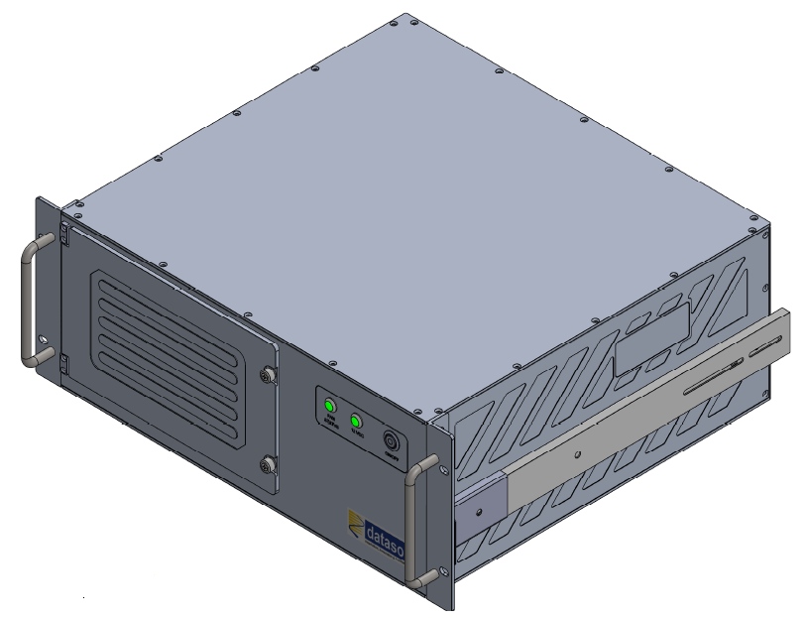

**Fig 1: cPCI chassis Image**

**1.2.2. KVM:**

The total Hight of KVM is 2U, 1U is for display (Top plate) and 1U is for keyboard (Bottom plate). The KVM will be 19” rack mountable. Slides are fixed to the KVM unit for mounting it on the rack and also for easy access.

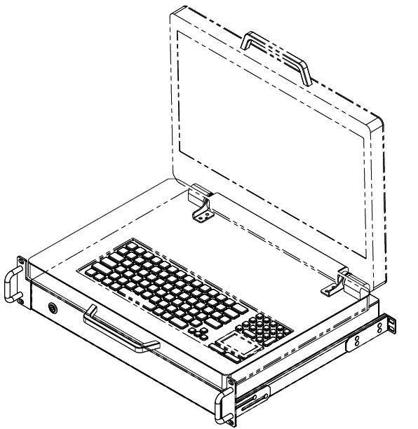

**Fig 2: KVM Image**

### 1.3. REFERENCE DOCUMENTS

The following list of references may be helpful for you to understand the concept of the custom design.

QTP: Qualification Test Procedure.

## 1.4. LIST OF DELIVERABLES

As per the Purchase Order Deliverable are listed below :

|  |  |  |
| --- | --- | --- |
| **SL No** | **Item Description** | **Quantity** |
| 1 | **Model No: -**  cPCI Based Advanced Launch Computer | 20 Sets |
| **Model No:**  19” rack mount 2U, 18.5 /19” Display with keyboard and touch pad with mating cables. |
| 2 | Cat 6 Gigabyte Ethernet cables terminated with RJ45 connectors – 10m length | 20 Sets |
| 3 | Cat 6 Gigabyte Ethernet cables terminated with RJ45 connectors – 5m length: | 20 Sets |
| 4 | VGA Splitter for extending VGA output up to 50m (Startech or EQVU) | 05 sets |
| 5 | Red Hat Enterprises Linux 7.5 or Higher Workstation license and media | 02 Nos |
| 6 | External USB based DVD drive | 05 Nos |
| 7 | Display Port/DVI to VGA adaptor cable of length 3m (Startech or EQVU) | 10 Nos |
| 8 | Circular power cable for KVM | 20 Nos |
| 9 | Packing Box for cPCI Chassis | 20 Nos |
| 10 | Packing Box for KVM | 20 Nos |
| 11 | Power Cord for cPCI Chassis | 20 Nos |
| **SPARES** | | |
| 1 | 3U cPCI XMC Carrier Card | 5 no’s |

## 2.0. IDENTIFICATION

## 2.1. cPCI Chassis Identification

The “cPCI BASED ADVANCED LAUNCH COMPUTER” supplied by DATASOL to ASL, Hyderabad will be hereafter identified as given below.

System : cPCI BASED ADVANCED LAUNCH COMPUTER

Part No **:** xxxx

S/N : xxxx

**Fig 3: cPCI Identification Image**

**Note:** Please suggest if any other details to be mentioned in above identification details (Name plate)

## 2.2. KVM Identification

System : KVM

Part No : xxxx

S/N : xxxx

**Fig 4: KVM Identification Image**

**Note:** Please suggest if any other details to be mentioned in above identification details (Name plate)

## HARDWARE DESCRIPTION FOR cPCI BASED ADVANCED LAUNCH COMPUTER

cPCI BASED ADVANCED LAUNCH COMPUTER having below mentioned modules assembled inside

3.1 SBC -- P/N: cPCI-3510BLD/5700E/M8

3.2 RTM -- P/N: cPCI-R3P00

3.3 1TB SSD --- P/N: DGS25-01TD81BWAQC-J27

3.4 POWER SUPPLY MODULE -- P/N: cPS-H325/AC

3.5 XMC GPU -- P/N: X3N1050TI-LFAB-DVI-B

3.6 cPCI-XMC Adapter Technical Specification

**3.1. SBC -- P/N: **cPCI-3510BLD/5700E/M8****

The cPCI-3510BLD is a 3U CompactPCI® PlusIO compatible processor blade with soldered 8GB DDR3L-1333/1600 ECC memory . The cPCI-3510BLD features an Intel® Core™ i7-5700EQ processor with Mobile Intel® QM87 Chipset. The cPCI-3510BLD supports 5th Gen Intel® Core™ i7.

The cPCI-3510BLD includes DVI-I port on faceplate, VGA switchable to J2 (RTM) by BIOS setting and it’s resolution supports up to QXGA 2048x1536 pixels@75Hz, 32-bits. It has 2x Gigabyte Ethernet controllers, 1x USB 3.0 port, 2 x USB 2.0 port, CFast socket and SATA connector, PS/2 Keyboard/Mouse combo port, Line-in and Line-out port, 1 x DB-9 RS-232/422/485, Operating Temperature: -20°C to +70°C, Storage Temperature: -50°C to +100°C.

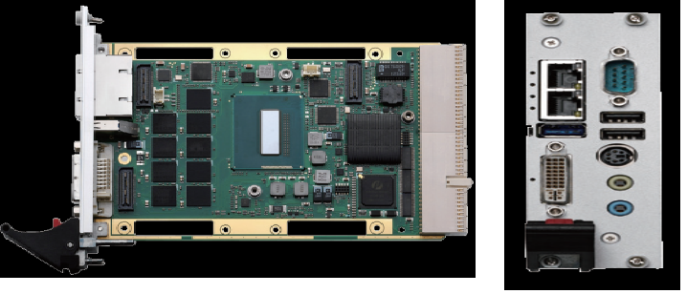

**Fig 5: **cPCI-3510BLD/5700E/M8 Image****

****cPCI-3510BLD/5700E/M8** Specifications:**

* Intel® Core™ i7-5700EQ Processor 2.6GHz, 3.4GHzTurbo
* 8GB DDR3L-1333 SDRAM ECC soldered
* Mobile Intel® QM87 Chipset
* DVI-I port on faceplate, VGA selected through BIOS setting
* Resolution supports up to QXGA 2048x1536 pixels@75Hz, 32-bits
* 2x Gigabyte Ethernet controllers
* 1x USB 3.0 port, 2 x USB 2.0 port
* CFast socket and SATA connector
* PS/2 Keyboard/Mouse combo port
* Line-in and Line-out port
* 1 x DB-9 RS-232/422/485
* Operating Temperature: -20°C to +70°C
* Storage Temperature: -50°C to +100°C

****cPCI-3510BLD/5700E/M8 Block Diagram****

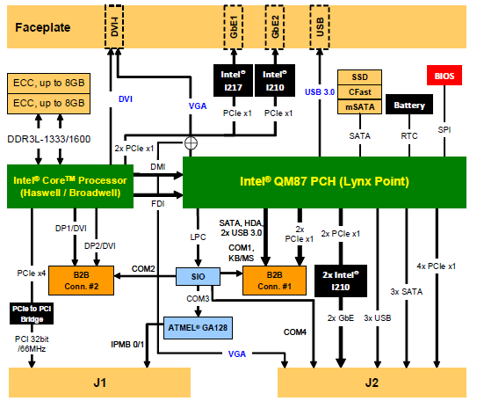

**Fig 6: **cPCI-3510BLD/5700E/M8** Block Diagram**

### 3.2. cPCI-R3P00 RTM Technical Specifications

* P/N: cPCI-R3P00
* 1 x VGA port
* 2 x USB 2.0
* 2 x COM ports
* 3 x SATA ports
* 2 x Ethernet ports
* Board Size: 100mm x 50mm

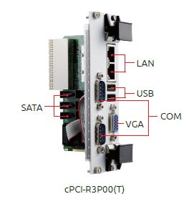

**Fig 7: cPCI-R3P00 RTM Image**

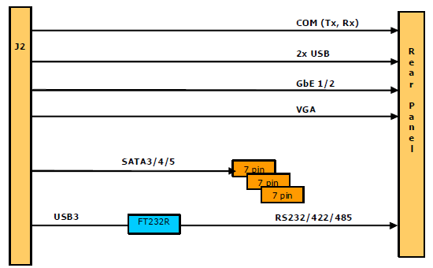

**Fig 8: cPCI-R3P00 Block Diagram**

### 3.3. 1TB SSD Technical Specification

### P/N: DGS25-01TD81BWAQC-J27

* 2.5” SATA SSD
* SATA III 6Gb/s
* Flash Type: MLC
* Max. Power Consumption: 6 W
* Sequential R/W : 520 / 480 MB/s
* Dimension (W x L x H): 69.85 X 100.0 X 6.9 mm
* MTBF: 3 million hours
* Storage Temperature: -55°C ~ +95°C
* Operational Temperature: -40°C ~ +85°C

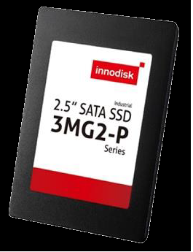

**Fig 9: SSD**

### 3.4. Power Supply Module Technical Specification

* P/N: cPS-H325/AC
* 3U CompactPCI® 8HP form factor
* 250 W DC output
* Hot swappable
* Input Voltage: 90-264 ± 10% VAC
* Input Frequency: 47-63 ±5% Hz
* Input Current: 2.8 A @ 115 VAC, 1.4 A @ 230 VAC
* Output Voltage/Current:

5V: Typical 25.0A, Maximum 33.0A

3.3V: Typical 18.0A, Maximum 33.0A

+12V: Typical 5.0A, Maximum 6A

-12V: Typical 0.5A, Maximum 1.5A

* Status LED:

Green: Valid I/P Voltage

Amber: Critical fault

* Operating Temp: 40 °C to +70 °C
* Storage Temp: -45˚C to +85˚C

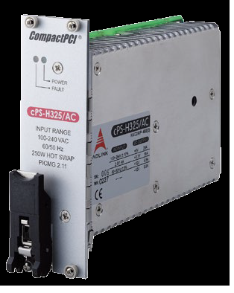

LICATIO **Fig 10: cPS-H325/AC Image**

**3.5. XMC GPU Technical Specification**

* P/N: X3N1050TI-LFAB-DVI-B
* GPU Chipset: NVIDIA GeForce GTX 1050Ti
* GPU: Clock 620 MHz
* NVIDIA® CUDA™ Cores 768
* Maximum Digital Display Support: 3840x2160
* Display Interface: 4* DVI or 4* HDMI via VHDCI
* Floating Point Performance: 952.32 GFLOPS
* Memory Size: 4GB GDDR5
* Memory Clock: 7.0 Gbps
* Memory Interface Width: 128 bit
* Memory Bandwidth (GB/sec): 112
* Maximum Board Power Consumption (W): 30 W

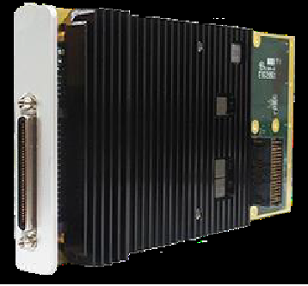

**Fig 11: XMC Card**

### 3.6. cPCI-XMC Adapter Technical Specification:

* Adapt one XMC.3 (PCI Express VITA 42.3) module to a 3U compact PCI/PXI
* Fan provides ~8 CFM cooling air directly on module
* PCI/PCI-X 64 bit, 133MHz interface
* XMC.3 PCI Express, 4 lane interface
* 490 MB/s sustained rate (host dependent)
* IEEE 1384 XMC mechanicals
* 3U height
* Clock Rates: 133 MHz maximum may be configured to 33 or 66 MHz limit by jumper
* Power Consumption: 3.3V @ 1A maximum (adapter only)
* Bit Rate per lane: 2.5 Gbps
* Ref Clock: 100 MHz
* Environmental ratings for -40 to 85C

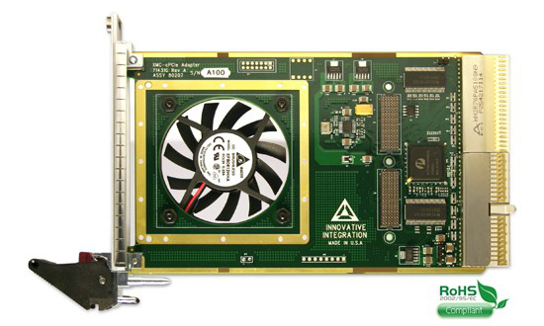

**Fig 12: cPCI-XMC Adapter Image**

## HARDWARE DESCRIPTION FOR KVM

KVM having the below mentioned modules assembled inside

* 1. Display (P/N: G185HAN01.0)
  2. Keyboard With Touch Pad (P/N: EKSB-97-TP)
  3. AC to DC Power Supply (P/N: LFA75F-12)
  4. EMI-RFI Filter (P/N: EF-1B006B20E-C02)
  5. Connectors
  6. **Display (P/N: G185HAN01.0)**

**Technical Specification:**

* Pixels H x V: 1920x1080
* 18.5” size display
* Support Color: 16.7M colors, True 8 bit
* Active Area: 408.96 (H) x 230.04 (V)
* Contrast Ratio: 1000 (Typ.)
* Screen Diagonal: 469.16(18.47”)
* Viewing Angle: 89/89/89/89
* Nominal Input Voltage VDD: 5 V (Typ)
* Operating Temperature: -20~ 70°C

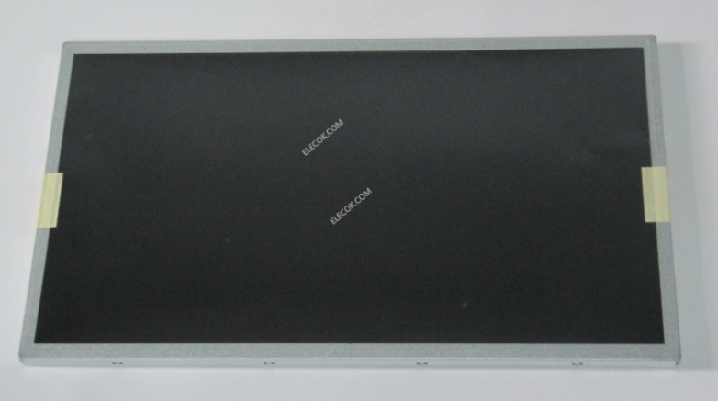

**Fig 13: Display Image**

* 1. **Keyboard With Touch Pad (P/N: EKSB-97-TP)**

**Technical Specification:**

* Material: Industrial Silicon Rubber
* Power: USB 60mA@5V
* Connectivity: USB
* Standard: IP67
* LED: Green
* With Integrated Touch Pad
* Operating Temperature: -40~ 70

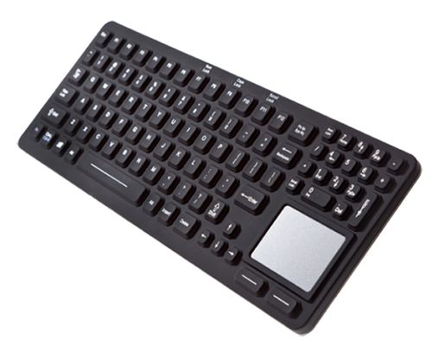

**Fig 14: Keyboard & Touch Pad**

* 1. **AC to DC Power Supply (P/N: LFA75F-12)**

**Technical Specification:**

* MAX Output Wattage: 75.6
* AC I/P: 85~264 VAC
* DC Output: 12V
* Current rating : 6.3 A
* I/P Frequency: 50 / 60 Hz (47 - 63)
* Operating Temperature: -10 to +70C

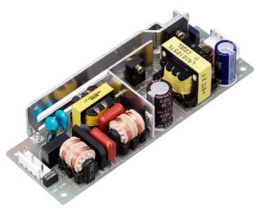

**Fig 15: Power Supply Image**

* 1. **EMI-RFI Filter (P/N: EF-1B006B20E-C02)**

EF-1B006B20E-C02 basically are passive electronic devices that are used to suppress conducted interference that is found on a signal or power line. RFI/EMI Filter will suppress the interference created by other equipment and the interference of the module or system itself, with the desired result being improvement to the immunity from EMI signals in the surrounding setting.

RFI/EMI Filter works by presenting a significantly higher resistance to higher frequency content. In other words, the low pass design of the RFI/EMI Filter (the combination of shunting capacitors and series inductors) results in the restriction/impeding of the flow of high frequency signals, effectively shorting it to ground. The final result of the RFI/EMI Filter is that it reduces and attenuates the unwanted signal strength, thereby having a minimal effect on other components or devices.

**Technical Specification**

* Mounting : Chassis type
* High Voltage test for 60 sec.: 2 KVAC between P &amp; N shorted together &amp; Earth
* Insulation Resistance at 500 VDC: 300 M ohms Min. between P &amp; N shorted together & amp; Earth
* Voltage Drop: 1 Volt . Max.
* Operating Temperature: 0°C ~ 85°C
* Input Connection: Fast On 6.3 X 0.8 mm / Solder-type

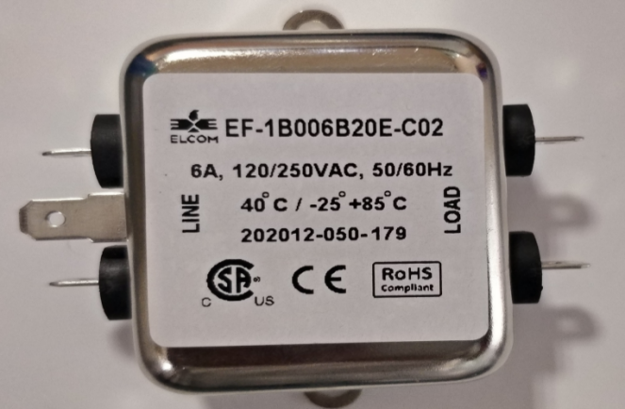

**Fig 16: EMI-RFI Filter Image**

* 1. **Connectors**

For AC Power I/P 3-Pin circular connector with part number **MS3102R-10SL-3P is provided.**

**For Display input Standard DVI Connector is provided**

**Both the connector provided on the rear side of the KVM.**

**With the KVM unit, a standard length of DVI Male to Male cable and power mating cable with one end having circular connector with part number MS3106F-10SL-3S is provided.**

1. **Test Set-up**

**Fig 17: Test Set-up Image**

1. **Functional Testing for cPCI Based Launch Computer & KVM**

Resource Required For Testing:

|  |  |  |
| --- | --- | --- |
| **SL.No.** | **Items** | **Qty** |
| 1 | Full Assembled cPCI Chassis | 1 |
| 2 | Full Assembled KVM | 1 |
| 3 | USB Keyboard /Mouse | 1 |
| 4 | DVI Cable | 1 |
| 5 | RJ45 Cable | 1 |
| 6 | Circular Power cable for KVM | 1 |
| 7 | USB cable for KVM I/P | 1 |
| 8 | 3-Pin Power chord for cPCI Chassis | 1 |

* 1. Functional Test is to be carried out on the cPCI Based Launch Computer:

|  |  |
| --- | --- |
| **SECTION** | **TEST** |
| 6.1.1 | CPU |
| 6.1.2 | RAM |
| 6.1.3 | SSD |
| 6.1.4 | USB |
| 6.1.5 | ETHERNET |
| 6.1.6 | SERIAL PORT |
| 6.1.7 | VGA |
| 6.1.8 | DVI |
| 6.1.9 | GPU |
| 6.1.10 | KVM KEYBOARD |
| 6.1.11 | KVM TOUCHPAD |

**6.1.1. CPU TEST:**

|  |  |
| --- | --- |
| TEST OBJECTIVE | To check for the CPU type & speed. |
| TEST PREREQUISITES | AC Power input for switching ON the cPCI Chassis & KVM |
| TEST PROCEDURE | Boot in Linux OS, go to the Console Screen, Type # **cat /proc/cpu info.**  This will provide all the necessary information regarding the CPU. |
| EXPECTED OUTPUT | The CPU should be Intel® Core™ i7-5700EQ Processor 2.6GHz, 3.4GHz  (Ref below image) |

**Fig 18: Image of Processor details**

**6.1.2. RAM TEST:**

|  |  |
| --- | --- |
| TEST OBJECTIVE | To check for System RAM Capacity |
| TEST PREREQUISITES | AC Power input for switching ON the cPCI Chassis & KVM |
| TEST PROCEDURE | Power ON System. Boot in Linux OS, Go to the Console Screen, Type  # cat /proc/meminfo  This will provide all the necessary information regarding the memory installed and the free available memory. |
| EXPECTED OUTPUT | 8GB DDR3L-1333 (Ref below image) |

**Fig 19: Image of RAM Details**

**6.1.3. SSD TEST:**

|  |  |
| --- | --- |
| TEST OBJECTIVE | To check the functioning of SSD |
| TEST PREREQUISITES | AC Power input for switching ON the cPCI Chassis & KVM |
| TEST PROCEDURE | Power ON System. Boot in Linux OS, Go to the Console Screen  Type # sudo fdisk -l  This will display the size of the hard disk installed. |
| EXPECTED OUTPUT | Size of the SSD should be 1TB (Ref below image) |

**Fig 20: Image of SSD Details**

**6.1.4. USB TEST:**

|  |  |
| --- | --- |
| TEST OBJECTIVE | To Check the functionality of USB Port |
| TEST PREREQUISITES | AC Power input for switching ON the cPCI Chassis & KVM |
| TEST PROCEDURE | 1. Connect USB Keyboard to Standard USB 1 Connector in RTM the unit & Switch ON the unit. 2. Check that any no. Keys (randomly selected) on the Keyboard are functioning correctly. And, observe the NUM Lock & Caps Lock LEDs ON/OFF operation. 3. Repeat the above step for remain USB ports |
| EXPECTED OUTPUT | The above testing should be same in all 3 USB ports. |

**6.1.5.** **ETHERNET TEST:**

|  |  |
| --- | --- |
| TEST OBJECTIVE | To check the functioning of the Ethernet Port. |
| TEST PREREQUISITES | 1. AC Power inputs for switching ON the units, boot into Linux OS, configure IP Address to be set for LAN port as 192.168.1.100 and subnet mask as 255.255.255.0. 2. For the host system set the IP Address for LAN port as 192.168.1.101 and subnet mask as 255.255.255.0. |
| TEST PROCEDURE | 1. Open the console screen and type # **ifconfig** 2. This will give you all the IP address information. In console type **# ping 192.168.1.101** IP address of the host system pinging should happen without packet loss or any errors. 3. Repeat the test with the other LAN port |
| EXPECTED OUTPUT | Pinging should happen without any Packet Loss and errors. |
| FOR OTHER PORTS | The above testing should be same in all ports. |

**6.1.6. SERIAL PORT:**

|  |  |
| --- | --- |
| TEST OBJECTIVE | To Check the Serial Port |
| TEST PREREQUISITES | AC Power input for switching ON the cPCI Chassis & KVM |
| TEST PROCEDURE | Power ON System.  * In the COM port, loop back pin no 2 and 3 .  * Type the minicom –s command in terminal  * Select the “serial port setup” option then enter.  * Press A to move the cursor in “serial device” delete modem and type ttyS0 then enter  * After changing the Device name ,  Press the E key to enter Comm Parameters then press C to select the baud rate (default is 9600 ).and press enter key.  * After selecting the Baud rate press the F key to change the Hardware Flow control, By default it’s Yes , press F it will change to NO and press enter key.  * Select “Save Setup as dfl” and press enter key  * After Configuration Select Exit  * Type any text in the keyboard the same will be displayed on the screen. By removing the loop back type some text in the keyboard it will not be displayed on the screen.  * Press CTRL+A then Z to bring up the menu to exit from minicom, then press “X” to “exit and reset”.  * After pressing X it will ask the permission to exit minicom, Select yes and press Enter Key. |
| EXPECTED OUTPUT | The typed letters should be exactly displayed on the screen, without any junk data |

**6.1.7. ON board VGA TEST:**

|  |  |
| --- | --- |
| TEST OBJECTIVE | To Check the VGA Port Resolution |
| TEST PREREQUISITES | AC Power input for switching ON the cPCI Chassis & KVM |
| TEST PROCEDURE | Boot with Linux OS Open the console Screen and Type #xrandr then check for 1920x1080 resolutions. |
| EXPECTED OUTPUT | The screen resolution should be 1920x1080 and the display should be clearly visible. |

**6.1.8. ON board DVI TEST:**

|  |  |
| --- | --- |
| TEST OBJECTIVE | To Check the DVI Port Resolution |
| TEST PREREQUISITES | AC Power input for switching ON the cPCI Chassis & KVM  Note: On BIOS, Please select display o/p as front |
| TEST PROCEDURE | Boot with Linux OS Open the console Screen and Type #**xrandr** then check for 1920x1080 resolutions. |
| EXPECTED OUTPUT | The screen resolution should be 1920x1080 and the display should be clearly visible. |

**Note : R**emove GPU card and test the on board VGA & DVI as mentioned above.

**6.1.9. XMC GPU TEST:**

|  |  |
| --- | --- |
| TEST OBJECTIVE | To Check the XMC DVI Port Resolution |
| TEST PREREQUISITES | AC Power input for switching ON the cPCI Chassis & KVM |
| TEST PROCEDURE | Boot with Linux OS Open the console Screen and Type #**xrandr** then check for 1920x1080 resolutions. |
| EXPECTED OUTPUT | The screen resolution should be 1920x1080 and the display should be clearly visible. |
| FOR OTHER PORTS | The above testing should be same in all ports. |

**6.1.10. KVM KEYBOARD**

|  |  |
| --- | --- |
| TEST OBJECTIVE | To Check the functionality of KVM Keyboard |
| TEST PREREQUISITES | AC Power input for switching ON the cPCI Chassis & KVM |
| TEST PROCEDURE | 1. Connect USB male to male cable from KVM rear side USB port to cPCI chassis any USB port & Switch ON the both the units. 2. Check that any no. Keys (randomly selected) on the Keyboard are functioning correctly. And, observe the NUM Lock & Caps Lock LEDs ON/OFF operation. |
| EXPECTED OUTPUT | Same should be displayed on the screen |

**6.1.11. KVM TOUCH PAD**

|  |  |
| --- | --- |
| TEST OBJECTIVE | To Check the functionality of KVM Touch pad |
| TEST PREREQUISITES | AC Power input for switching ON the cPCI Chassis & KVM |
| TEST PROCEDURE | 1. Connect USB male to male cable from KVM rear side USB port to cPCI chassis any USB port & Switch ON the both the units. 2. Move the finger on touch pad & check if the cursor is moving in line to the   direction moved .   1. Click on left/right button touch pad and see the options select on the display screen. |
| EXPECTED OUTPUT | The movement should happen as per direction moved and left/right buttons should open options. |

1. **ENVIRONMENTAL TESTING :** These tests are done to test and evaluate performance of the time(s) at the specified environmental conditions.

**Entest Applicable Matrix For The Items**

|  |  |  |  |  |  |  |  |
| --- | --- | --- | --- | --- | --- | --- | --- |
| **Sl No** | **GSE** | **EMI/EMC** | **ESS\*** | **Damp**  **Heat** | **High**  **Temp.** | **Low Temp** | **Random**  **Vibration** |
| 1 | cPCI Based Advanced Launch Computer | NA | A | A | NA | NA | NA |
| 2 | KVM | NA | NA | A | A | A | A |

**Batch ENTEST Specifications for Class -2B GSE With LCD Display**

| **Sl. No.** | **Description** | **Specification** | **Remarks** |
| --- | --- | --- | --- |
| 1 | High Temperature | +55°C±3° for 4 Hours | PREET, INSET & POET  INSET in Last 30 Min |
| 2 | Low Temperature | -20°C±3° for 4 Hours | PREET, INSET & POET  INSET in Last 30 Min |
| 3 | Damp Heat | 450 C (RH 95%)for 8 Hours | PREET at ambient  INSET at 7 ½ Hours. |
| 4 | Random Vibration (Three axis) | 5-20 Hz, (6db per octave)  desirable 20-50 Hz:0.02g2/Hz  then rolling up to 0.001g2/Hz at 500 Hz.  **Duration:** 30 minutes cumulative in 3axis | PREET, INSET & POET |

**Note:** Since KVM is inside the chamber, We can not test the Keyboard & Touch pad functional

**ESS Test Details for cPCI Based Advanced Launch Computer**

|  |  |  |  |
| --- | --- | --- | --- |
| **S.No** | **Parameter** | **Test Description** | **Remarks** |
| 1 | Thermal cycling | Temp Range: -20° C to +55° C  Dwell Time : 60 Min  Rate: AT 10° C/Min  No.of cycles: 6 | PREET & POET at ambient.  INSET 2 times every cycle:  1st before switching OFF at the end of higher temp dwell period. And, 2nd after switching ON at the end of the lower temp. dwell period. |
| 2 | Damp Heat | 45° C, RH 95%, for 8 Hours. Duration | PREET, INSET & POET  INSET at 7 ½ Hours |

1. **SIGNAL DETAILS For KVM:**

**Wiring Diagram**

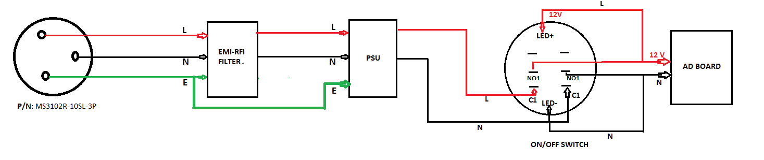

**Fig 21: Wiring Diagram**

* 1. **Connection details b/w panel mount power connector to EMI-RFI filter I/P**

|  |  |  |  |  |  |  |
| --- | --- | --- | --- | --- | --- | --- |
| **KVM PANEL Connector DETAILS** | **Pin no** | **Signal Description** |  | **EMI-RFI FILTER I/P** | **Pin no** | **Signal Description** |
| **MS3102R-10SL-3P** | Pin1 | LINE | ------> | **EF-1B006B20E-C02** | Pin 1 | LINE |
| Pin 2 | NEUTRAL | ------> | Pin 2 | NEUTRAL |
| Pin 3 | EARTH | ------> | Pin 3 | EARTH |

* 1. **Connection details b/w EMI-RFI filter O/P to Power supply I/P**

|  |  |  |  |  |  |  |
| --- | --- | --- | --- | --- | --- | --- |
| **EMI-RFI FILTER O/P** | **Pin no** | **Signal Description** |  | **POWER SUPPLY I/P** | **Pin no** | **Signal Description** |
| **EF-1B006B20E-C02** | Pin1 | LINE | ------> | **LFA75F-12** | Pin1 | LINE |
| Pin 2 | NEUTRAL | ------> | Pin 2 | NEUTRAL |
| Pin 3 | EARTH | -----> | Pin 3 | EARTH |

* 1. **Connection details b/w power supply O/P to switch I/P**

|  |  |  |  |  |  |  |
| --- | --- | --- | --- | --- | --- | --- |
| **POWER SUPPLY o/P** | **Pin no** | **Signal Description** |  | **ON/OFF Switch** | **Pin no** | **Signal Description** |
| **LFA75F-12** | Pin1 | LINE | ------> | **MP0045/1E2/BL/012** | C1 (Left) | LINE |
| Pin 2 | NEUTRAL | ------> | C1 (Right) | NEUTRAL |

* 1. **Connection details b/w Switch O/P to AD Board**

|  |  |  |  |  |  |  |
| --- | --- | --- | --- | --- | --- | --- |
| **POWER SUPPLY o/P** | **Pin no** | **Signal Description** |  | **AD Board**  **Jack** | **Pin no** | **Signal Description** |
| **MP0045/1E2/BL/012** | NO1(Left) | LINE | ------> | - | Pin1 | LINE |
| NO1(Right) | NEUTRAL | ------> | Pin2 | NEUTRAL |

* 1. **Connection details for Switch LED**

* Tap the wire from AD board Line and connect to the LED+

* Tap the wire from AD Board neutral and connect to the LED-

* 1. **External 1.8 Meters Power cable**

|  |  |  |  |  |  |  |
| --- | --- | --- | --- | --- | --- | --- |
| **KVM Side Mating Connector DETAILS** | **Pin no** | **Signal Description** |  | **Power SOCKET SIDE** | **Pin no** | **Signal Description** |
| **MS3106F-10SL-3S** | Pin1 | LINE | -----> | **3-PIN PLUG** | Pin1 | LINE |
| Pin2 | NEUTRAL | ------> | Pin2 | NEUTRAL |
| Pin3 | EARTH | ------> | Pin3 | EARTH |

1. **cPCI Based Advanced Launch Computer Images**

**Front View**

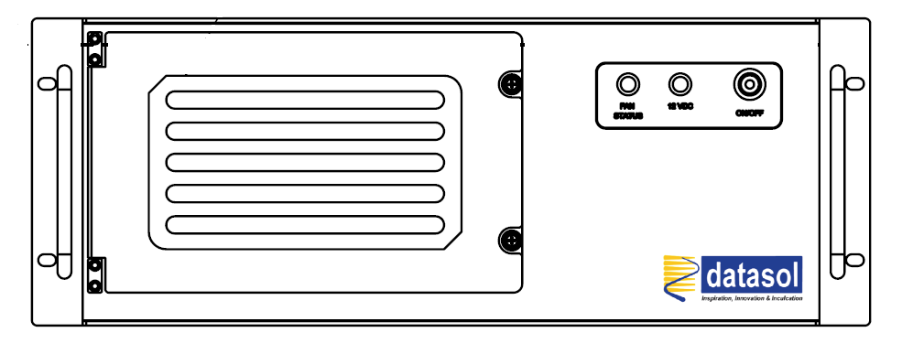

**Fig 22: cPCI Front View**

**Rear View**

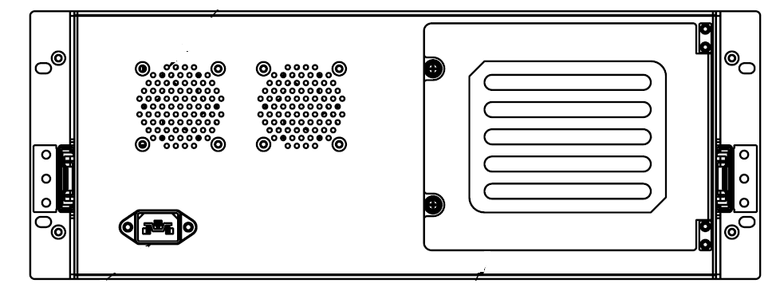

**Fig 23: cPCI Rear view**

**Side View**

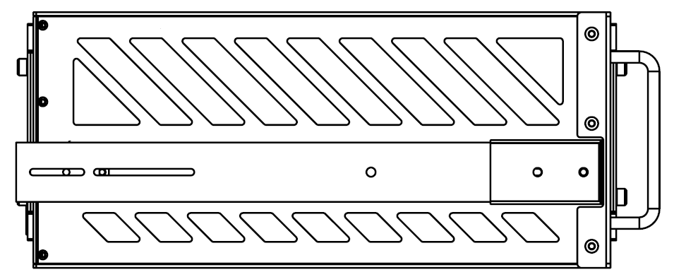

**Fig 24: cPCI Side view**

1. **KVM Images**

**Front View**

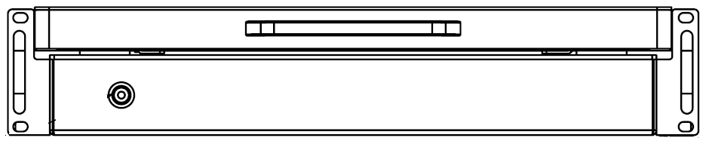

**Fig 25: KVM Front view**

**Rear View**

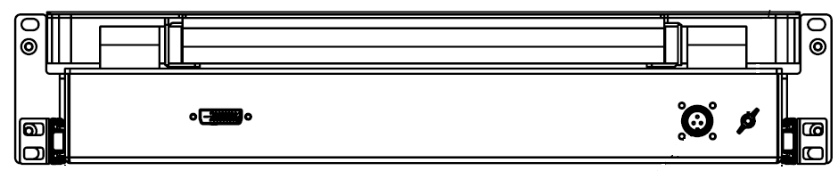

**Fig 26: KVM Rear view**

**Side View**

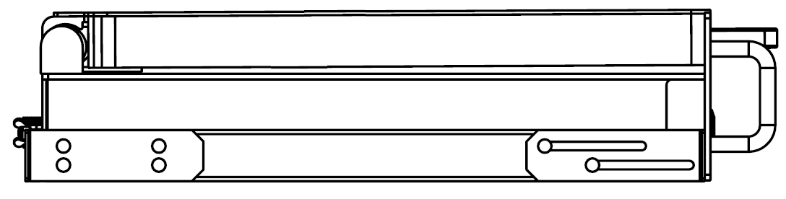

**Fig 27: KVM Side view**

1. **PHYSICAL TEST REPORT**

|  |  |
| --- | --- |
| **DATE** |  |
| **DATASOL PART NUMBER** |  |
| **ASL PART NUMBER** |  |
| **UNIT SERIAL NUMBER** |  |

**PHYSICAL CHECK :**

|  |  |  |  |
| --- | --- | --- | --- |
| **S.NO** | **TEST** | **REQUIREMENT** | **RESULT** |
| 1 | KVM & cPCI Chassis damages check | No damages | OK /NOT OK |
| 2 | Mating of circular connectors proper fitment | Proper fitment | OK /NOT OK |
| 3 | All the circular connectors assembled properly to the chassis | Proper assembly | OK /NOT OK |

**DIMENSIONAL CHECK FOR KVM:**

|  |  |  |  |  |
| --- | --- | --- | --- | --- |
| **S.NO** | **DESCRIPTION** | **SPECIFIED DIMENSIONS(MM)** | **MEASURED DIMENSIONS (MM)** | **RESULT** |
| 1 | Width | xxx.x ± x.0 |  | OK /NOT OK |
| 2 | Height | xxx.x ± x.0 |  | OK /NOT OK |
| 3 | Depth | xxx.x ± x.0 |  | OK /NOT OK |
| 4 | Weight | xx Kgs |  | OK /NOT OK |

**DIMENSIONAL CHECK FOR cPCI Chassis:**

|  |  |  |  |  |
| --- | --- | --- | --- | --- |
| **S.NO** | **DESCRIPTION** | **SPECIFIED DIMENSIONS(MM)** | **MEASURED DIMENSIONS (MM)** | **RESULT** |
| 1 | Width | xxx.x ± x.0 |  | OK /NOT OK |
| 2 | Height | xxx.x ± x.0 |  | OK /NOT OK |
| 3 | Depth | xxx.x ± x.0 |  | OK /NOT OK |
| 4 | Weight | xx Kgs |  | OK /NOT OK |

**RESULT : OK / NOT OK**

|  |  |
| --- | --- |
| **TESTED BY:** | **VERIFIED BY:** |
| **DESIGNATION:** | **DESIGNATION:** |
| **SIGN:** | **SIGN:** |

**Note:** Actual dimensions will be filled after final drawings are made.The Sample format of Physical inspection report shown above.

1. **FUNCTION TEST REPORT**

|  |  |
| --- | --- |
| **DATE** |  |
| **DATASOL PART NUMBER** |  |
| **ASL PART NUMBER** |  |
| **UNIT SERIAL NUMBER** |  |

|  |  |  |  |
| --- | --- | --- | --- |
| **S.No** | **TEST** | **REQUIREMENT** | **RESULT** |
| 1 | **FUCTIONALITY OF KVM & cPCI Chassis:**  After switching ON the power to KVM & cPCI chassis check if the system got booted and display is seen on the screen of the unit. Set the required Resolution and check if the set resolution is supported and displayed on the screen. | * cPCI Chassis should boot in to Linux OS .  * Resolution up to 1920 X 1080 | OK / NOT OK |
| 2 | **FUNCTIONALITY OF KEYBOARD / Touch Pad:**  After switching ON the power to KVM & cPCI chassis check the system gets booted and display is seen on the screen of the KVM. Check the functionality of the keyboard by typing & functionality of Touch Pad by moving or changing the position. | * Test by pressing the keys on keyboard & check the same is displayed on the screen of the display.  * To test the Touch pad, Move the finger on touch pad l & check if the cursor is moving in line to the direction moved . Click on left/right buttons | OK / NOT OK |

|  |  |
| --- | --- |
| **TESTED BY:** | **VERIFIED BY:** |
| **DESIGNATION:** | **DESIGNATION:** |
| **SIGN:** | **SIGN:** |